**J M Baxi Group**

Privilege Access Granting – SAP

Standard Operating Policy and Procedures

**Contents**

**1.** **Standard operating policy & procedure (SOPP)** 3

**1.1** **Introduction** 3

**1.2** **Document Review and approval** 3

**2.** **Scope** 4

**3.** **SAP Privilege User Access Management** 4

**Appendix – List of J M Baxi Group entities** 8

# **Standard operating policy & procedure (SOPP)**

## **Introduction**

A Standard Operating Policy & Procedure (SOPP) is a comprehensive document that outlines a series of step-by-step instructions created by an organization to guide workers in executing both complex and routine tasks. SOPPs are designed to ensure efficiency, maintain high-quality output, and promote consistency in performance. They play a crucial role in supporting process excellence by streamlining operations and reducing variability in work practices.

This SOPP aims to achieve the following objectives:

* + 1. Act as a guide and reference document to stakeholders at all levels of the organization
    2. Clearly communicate activities and help to achieve consistency in operational procedures.
    3. Create accountability by assigning responsibilities at each stage of the lifecycle.
    4. Aid governance by documenting auditable processes and detailing control elements at each stage of the lifecycle.

## **Document Review and approval**

This SOP shall be subjected to an annual review (or more frequently) as determined by author of the document. The assigned reviewer shall ensure the continued accuracy and validity for use of the document.

Revision history

| **Version** | **Created By** | **Document Approved By** | **Date Approved** | **Revision** |
| --- | --- | --- | --- | --- |
|  |  |  |  |  |

| **SOPP Number** | XX |
| --- | --- |
| **SOP Owner** | CTO – Manish Jaiswal |
| **IT Applications** | SAP HANA |
| **Guidelines / Policy reference** |  |
| **SOPP Cross References** |  |

# **Scope**

This procedure applies to all users of the organization’s information systems, as well as personnel responsible for managing user accounts or controlling access to information assets and systems, including Business Owners and administrators of centrally managed accounts.

The purpose of this document is to outline the process for granting access to Debug, SAP_ALL, SAP_NEW, and Firefighter IDs.

# **SAP Privilege User Access Management**

Access Request Submission - All requests for authorizations related to SAP*, SAP_ALL, SAP_NEW, Debug, and Firefighter IDs must be submitted through a Service Request (SR) ticket in the AskIT tool, specifying the required duration of access and the purpose for which the access is being taken.

**Approval for SAP_ALL and SAP_NEW Access**

Requests for SAP_ALL or SAP_NEW access must go through the standard three-level approval process. Prior to raising the service request ticket, approval must be obtained from the CTO, and the approval should be embedded within the SR ticket.

The CTO's approval email must include the following:

- The duration for which the access is granted.

- A justification outlining the reasons for granting the access.

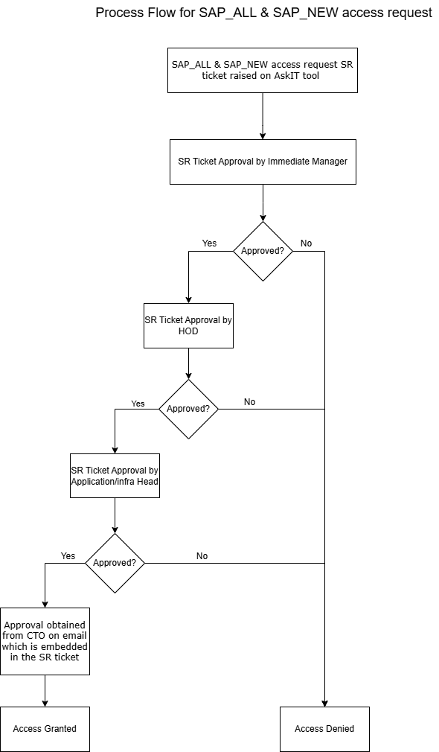

**Debug Access Approval**

Debug access will be granted upon approval via email from the DGM IT and must be attached to the ticket when raising the SR ticket.

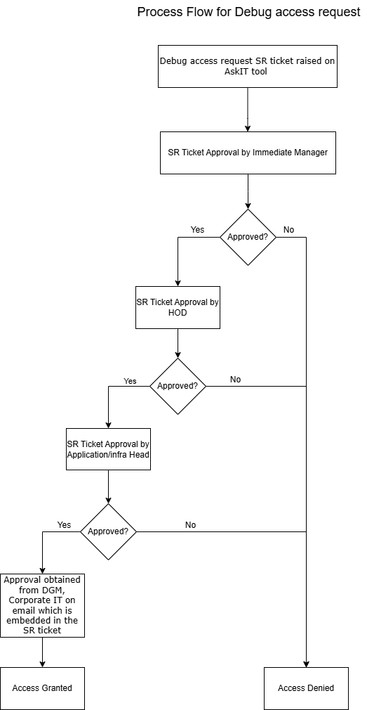

**Firefighter ID Access Approval**

In case access to Firefighter ID is required, approval must be obtained from either the DGM IT or the Infra Head for infrastructure-related access. Requests for Firefighter ID access must be raised through a service request ticket in the AskIT platform, which should include the approval email received from the DGM IT or Infra Head, depending on the case.

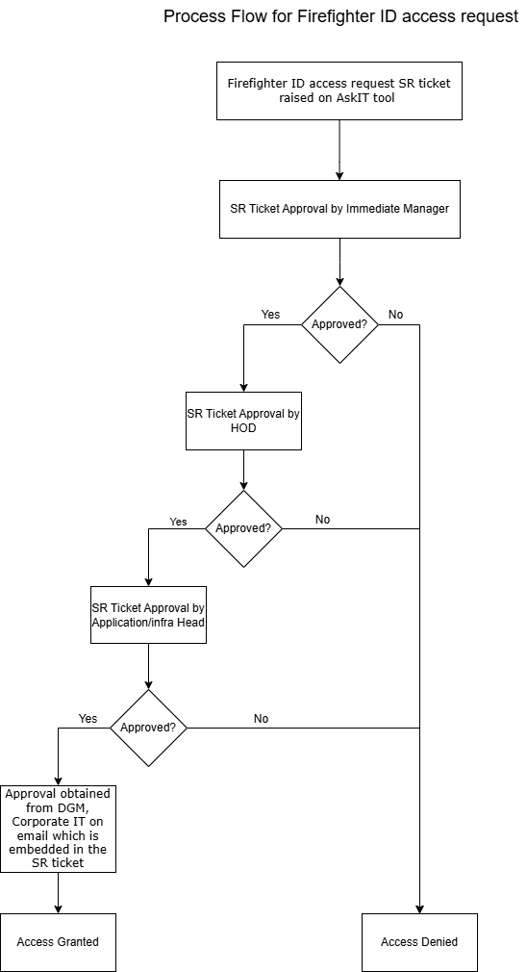

# **Appendix – List of J M Baxi Group entities**

